March 2023
123 Main St. PO Box 190,
Pelly, SK S0A 2Z0
PH: (306) 595-2124
www.pelly.ca
Email: town.pelly@sasktel.net
Regular Office Hours
Tuesday & Wednesday
9 am to 12 & 1 to 5 pm
Thursday 9 am to 12 & 1-6 pm
Closed to public Monday’s & Friday’s
EXCEPT for Statutory Holidays.

Council Meetings
Council Meetings are regularly scheduled to be 6:00PM on the SECOND Wednesday of each month. Deadline for agenda submissions is the Thursday prior.
Upcoming Meeting Dates:
Apr 12, May 10, June 14 2023
at Council Chambers

Transfer Station Hours
Every Wednesday by appointment only. Appointments to be received at office by previous Thursday phoning
(306)595-2124.

Garbage Collection
Household garbage pick-up from the BLACK garbage containers
Bi-weekly on Wednesday’s
Paper Recycle Bins
Located at the
Town Shop yard

Regular Library Hours for 2023
Parkland Regional Library Pelly branch:
Tuesdays from 11 am to 5pm
Thursdays from 1pm to 7pmBy appointment or curbside delivery
Phone: 306-595-2243
Email: pelly@parkland.lib.sk.ca

Payment Types Accepted
E-transfer: town.pelly@sasktel.net
Debit/Credit(3% Fee on Credit Cards only) Cheque, EFT, and Cash

IMPORTANT NOTICES:

Utility Billing
Due to unforeseen circumstances, the first quarter utility billing will be delayed being mailed out. Please allow a delay of one to two weeks, which will mean they should be mailed out by early to mid April. We apologise for the inconvenience and appreciate your patience.

Sewer Blockages
Please notify the Village office if you have a sewer line blockage and require a contract service to fix the issue. This is to ensure if the blockage is on personal or village property, it will be compensated accordingly.

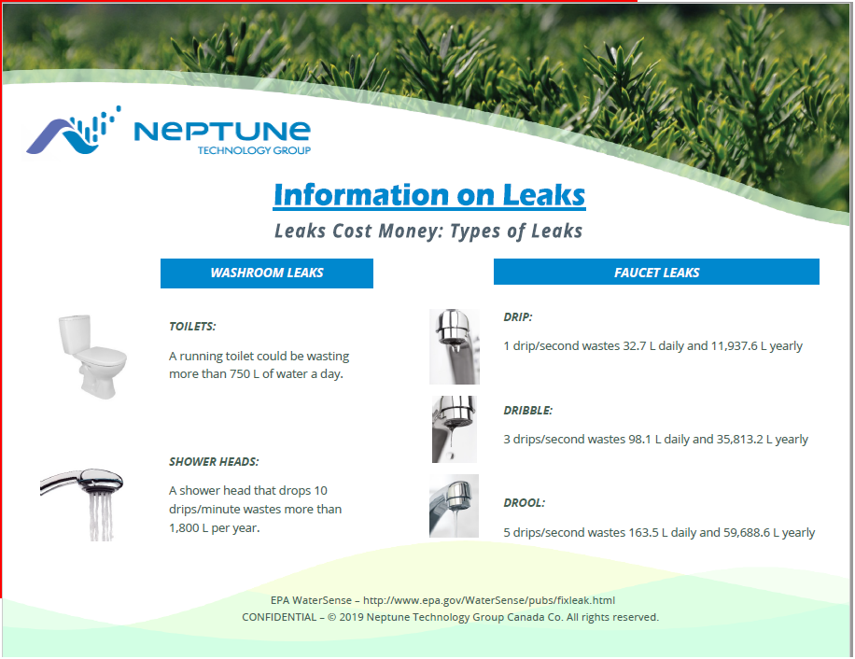

Vaccine Clinic – Vitality Vet Clinic
Vitality Vet Clinic will be providing their services at the Community Hall on Wednesday April 5 from 3:00-3:30 pm. Services provided are routine canine/feline vaccinations, deworming, flea and tick medications. No appointment required. Call 306-782-8387 with any questions.

Museum News
The Museum would like to extend a friendly invitation to join them for coffee, every Friday at 10 AM.
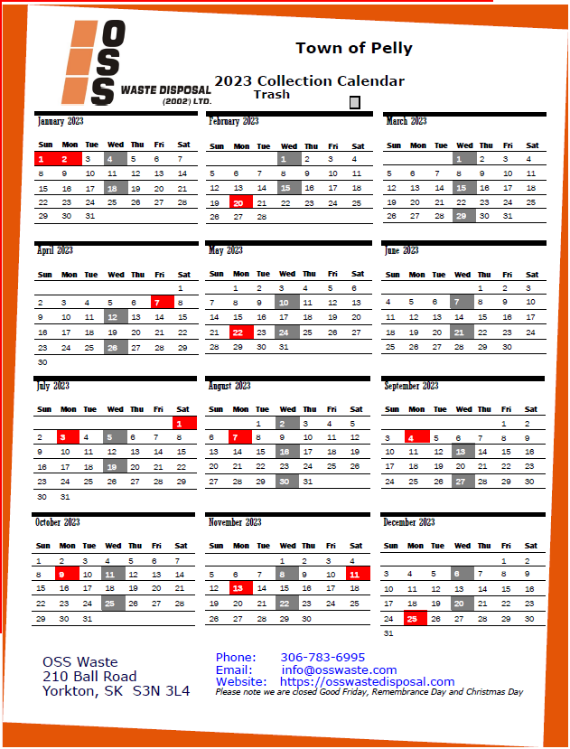  FACEBOOK EMERGENCY NOTIFICATION PAGE  Please join our Facebook Page:  New Village of Pelly  To receive immediate notification of:  Fire Evacuation, Water & Sewage Issues, Garbage Issues, Street, Village & Property Maintenance.  TRANSFER STATION HOURS  Wednesday 10:00 by appointment previous Thursday.  (Appointment made prior week is appreciated for work organization.)  VILLAGE OF PELLY WEBSITE  Please visit the Village website for any information you may require within.  https://www.pelly.ca | COMMUNITY EVENTS  PELLY SKATING RINK  Hours: Wednesday 6:00pm-9:00pm, Thursday 4:30pm-7:00pm, Friday 7:00pm-10:00pm, Saturday 1:00pm-4:30pm and 7:00pm -10:00pm, Sunday 1:00pm-5:00pm  Skating Fees: Daily $3.00, Student Seasonal $50.00, Adult Seasonal $75.00, Family(immediate)Seasonal $125.00  BINGO AT HAPPY HEARTS  Starts at 7:30PM  Every Friday & 1st and 3rd Wednesday of every Month  SOUP & SANDWICH AT HAPPY HEARTS  Menu: Soup, sandwich, dessert and beverage. Every 4th Friday of the Month 11:30 am to 1:00 pm  Take out orders available: Please call (306)595-2122.  COFFEE AT HAPPY HEARTS  Every Monday, Wednesday and Saturday 10:00AM – 11:00AM  Every Tuesday morning: Chair Yoga 10:00 am – 11:00 am  Free activities at Happy Hearts every Tuesday 2:00 pm various:  Cards, Board Games, Puzzles, Floor Curling, Pool, Shuffle Board, etc.  ACTIVE AGING EXERCISES  Every Thursday 10:00AM – 11:00 AM at Pelly Happy Hearts. Everyone Welcome Come join the fun!!  THE FRIENDS OF PELLY  The Friends of Pelly have been to Sarcan! To donate to the bottle drive “Drop & Go” is set up at Sarcan! Enter “Pelly playground.” More info: access www.sarcan.ca and look for “drop & go” section. Sarcan will mail your refund to the organization!!  The Friends of Pelly are a Dynamic Organization helping to revitalize the Pelly Community Park with the addition of an Activity Park for all ages to enjoy! If you are interested in volunteering a few hours now & then, volunteering is welcome for this exciting upbeat project! Please Email: elussier@SASKTEL.NET and your name can be added to our appreciated list of volunteers!

